**SPEAK UP, SPEAK KINDLY**

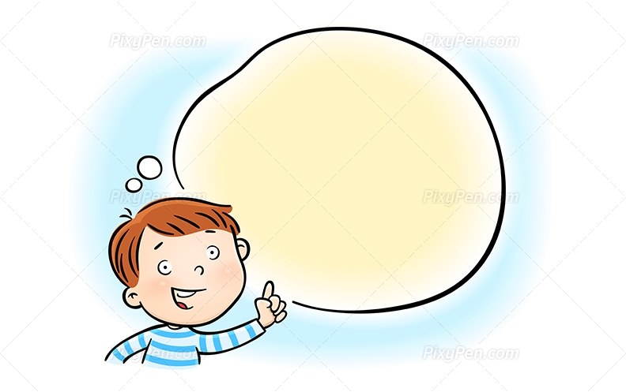

**My Name Is____________________________________**

**You can’t unsnap your bike helmet by yourself.**

Is it okay to ask for help?

YES NO

**You think your friend’s new haircut looks funny.**

Is it okay to say you don’t like how someone looks, or that you don’t like what they are wearing?

YES NO

**You and your friends are building with blocks, and you have an idea to build a bridge, but you aren’t sure if your friends will want to do that.**

Is it okay to speak up when you have an idea?

YES NO

**You see that a friend is spinning much too fast on the merry go round and can’t stop it.**

Is it okay to say something when someone might need help?

YES NO

**A friend tells you how to play a new game, but you don’t understand everything he said.**

Is it okay that you don’t understand or that you need to ask a question?

YES NO

**Your friend is afraid to climb on the playground bars and you think that’s silly.**

Is it okay to say you think someone’s feelings are silly or wrong?

YES NO

**You think that you got the best grade on the math test.**

Is it okay to say that you did something better than someone else?

YES NO

**Your friend has been using the magnifying glass for a long time and you want to use it to look at some bugs.**

Is it okay to say that you want someone to share or that you want something?

YES NO

**Your friend asks you to help him with a math problem, but you have to finish your reading and don’t have enough time.**

Is it okay to say no to someone if you aren’t able to do something?

YES NO

**You are watching a group of friends who are playing soccer, and you want to play with them too.**

Is it okay to say that you want to play with someone?

YES NO

**You hear a friend say something mean to another child.**

Is it okay to say that what someone says or does isn’t kind or fair?

YES NO

**You really like the poem your friend wrote.**

Is it okay to say something nice about someone or about something they did?

YES NO